Horizon Sensors Hardware Description
Clayton Gumbrell
23 December 2008
Hardware Version 1.1

Description
The horizon sensors consist of two versions – a visible light sensor and an infrared (IR) sensor. Each sensor provides two outputs (1 & 2).
The IR sensor is based on the ST60 sensor. It uses the same circuit as the Dexter Miniature Amplifier PCB, but duplicated for two sensors.
The visible sensor uses a BPW21 photo-diode. It uses the same circuit as the IR sensor, but with the gain reduced. This may in fact not be the ideal circuit, although it does work.
All sensors simply output a voltage proportional to the IR or visible light sensed. The output level is referenced from a 1.25V reference. The sensor outputs should be connected to ADC module channels.
The schematic details are in the document “IR_Horizon_Sensor_Head_V11b schematic.pdf”

PCB Layout
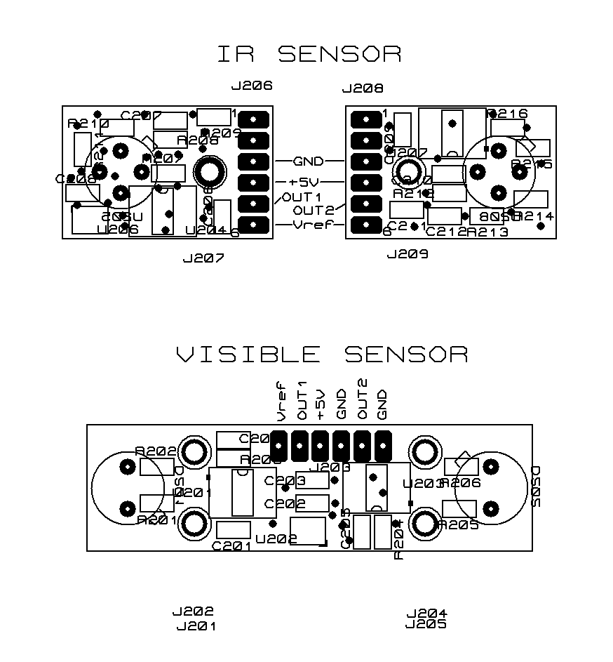
The visible sensor has a modification. A 1uF capacitor (0805 package) is added between pin 6 of U202 and GND. Scrap some solder mask off the GND ground-plane to attach the capacitor GND pin.
The sensors are designed to be mounted onto the appropriate sensor heads before the sensor devices are soldered to the PCB. This ensures that the sensor devices are positioned perfectly.
The IR sensor consists of two PCBs. Once mounted three wire links need to be placed between these PCBs (signals GND, +5V, and Vref). The connections to power and the ADC module can then be made. Connection wires should be directly soldered to the sensor PCB pads.

PCB Connections
J206 and J208 are the IR sensor connections.
J203 are the visible sensor connections
Connections | Signal | Description
J206 – 1 | - | Sensor thermistor – not used
J206 – 2 | - | Sensor thermistor – not used
J206 – 3 | GND | Connect to J208 – 3 and Ground (0V)
J206 – 4 | +5V | Connect to J208 – 4 and +5V
J206 – 5 | OUT1 | Output 1 to ADC
J206 – 6 | Vref output | Connect to J208 – 6
J208 – 1 | - | Sensor thermistor – not used
J208 – 2 | - | Sensor thermistor – not used
J208 – 3 | GND | Connect to J206 – 3 and Ground (0V)
J208 – 4 | +5V | Connect to J206 – 4 and +5V
J208 – 5 | OUT2 | Output 2 to ADC
J208 – 6 | Vref input | Connect to J206 – 6
J203 – 1 | Vref output | 1.25V reference to ADC channel
J203 – 2 | OUT1 | Output 1 to ADC
J203 – 3 | +5V | To +5V supply
J203 – 4 | GND | To ground (0V)
J203 – 5 | OUT2 | Output 2 to ADC
J203 – 6 | GND | To ground (0V) (optional)

